Group 5 Research Paper

Tianyu Zhang, Zhouyang Sheng, Rahat Khan, Thoma Glads Choppala

Sai Sharat Paila

20240215

**Introduction**

The NYPD Arrest Data dataset is a comprehensive collection of arrest records from the New York Police Department, providing a granular view of law enforcement activity throughout the city. This dataset typically includes details such as the type of offense, the location and time of the arrest, demographic information about the individuals arrested, and other pertinent details that can be utilized for a variety of analyses. It serves as a valuable resource for understanding crime patterns, informing public safety strategies, and enhancing transparency in law enforcement operations.

**Main Part**

**Key Insights into NYPD Arrest Demographics**

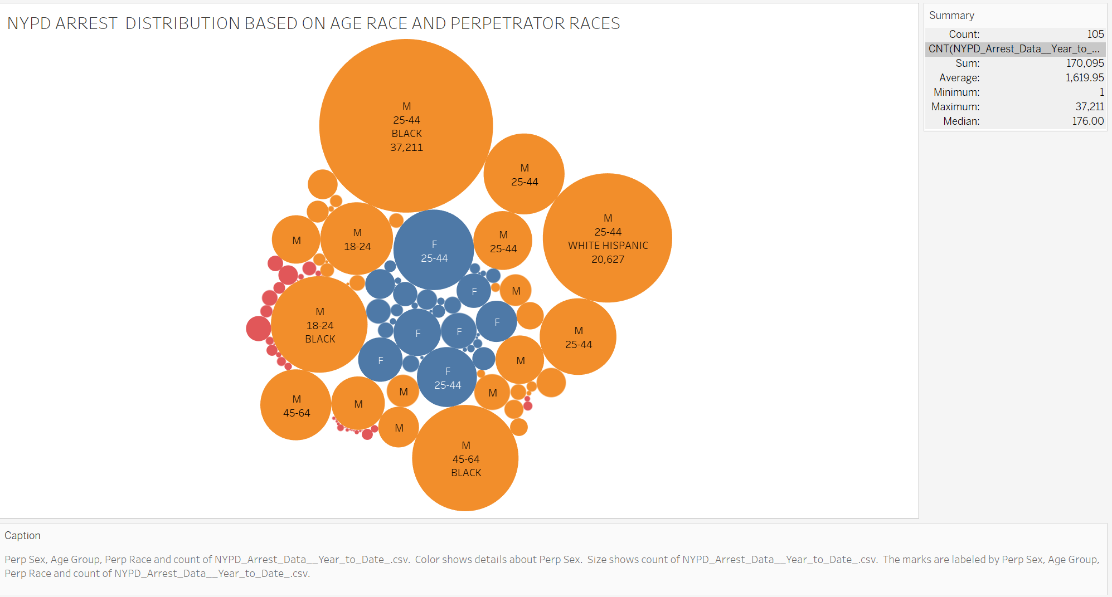

The graph using packed bubbles illustrates the NYPD arrest distribution by age, race, and perpetrator sex. The most prominent data point is for Black males aged 25-44, with the highest count of 37,211 arrests, which is a significant proportion of the total arrests. This data suggests that Black males in this age group are the most arrested demographic. The size of the circles represents the number of arrests, and the color distinction appears to represent gender, with larger circles for males in almost all age and race categories, indicating a higher number of arrests compared to females.

The graph also highlights disparities between racial groups within the same gender and age category. For instance, Black and Hispanic males aged 25-44 seem to have a much higher number of arrests compared to other races.

The analysis points towards specific demographic groups that might require focused social interventions and policing strategies. The data could be indicative of underlying social issues, potential biases in policing, or other factors contributing to these observed patterns. It is crucial for policymakers and community leaders to investigate the root causes behind these trends to address them effectively.

**NYPD Arrest Analysis by Offense Level and Perpetrator Sex**

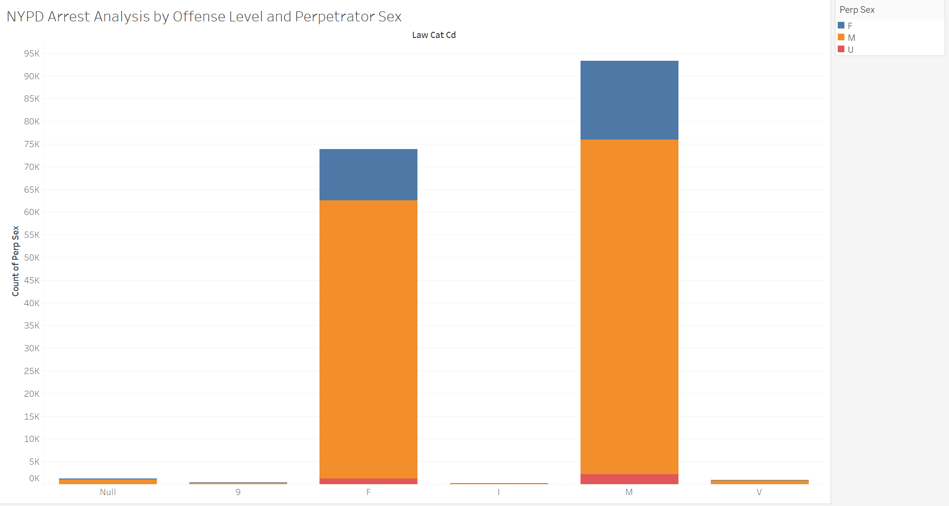

The NYPD Arrest Analysis by offense level and perpetrator sex reveals significant gender disparities across various crime categories. According to the data:

* **Felonies (F)**: There is a striking difference in arrests for felonies, with male arrests far outnumbering female arrests. This suggests that men are more likely to be involved in serious criminal activities that are classified as felonies.
* **Misdemeanors (M)**: Similar to felonies, misdemeanors also see a higher number of male arrests compared to female arrests. While these crimes are less severe than felonies, the gender gap persists.
* **Violations (V)**: Even in the least severe category of offenses, violations, males are again arrested more frequently than females.

The trend of higher male arrests is consistent across all levels of offenses. This pattern not only demands a deeper examination of the social and environmental factors that lead to such disparities but also highlights the necessity for targeted interventions to address the root causes of this gender imbalance in crime rates. The analysis, thus, serves as a crucial step in data-driven policy-making and community-focused crime prevention strategies.

**Demographic Distribution by Age and Gender**

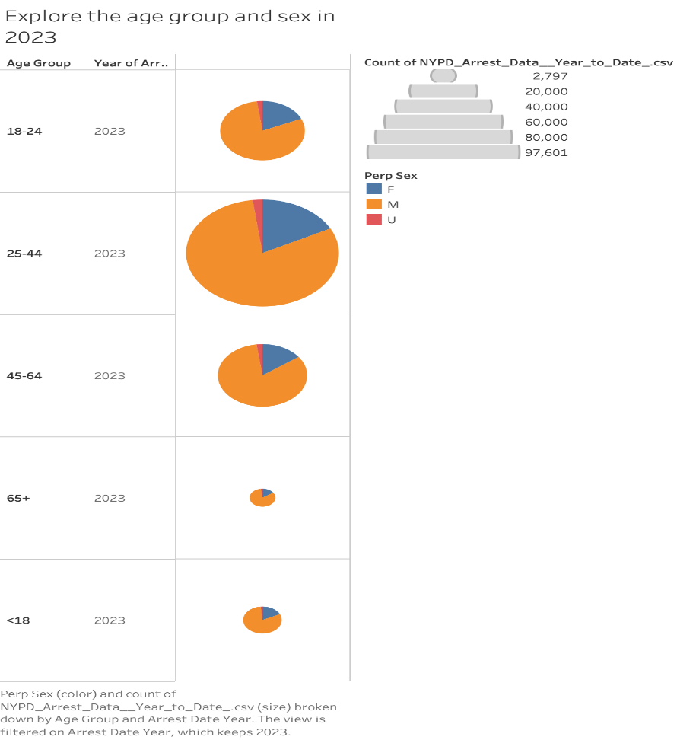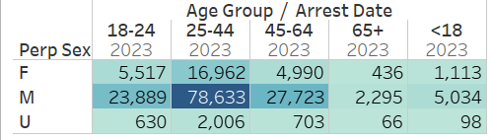

* The age group of 25-44 has the highest arrest count: 78633, especially among males, indicating a significant prevalence of criminal activity in this demographic.
* Males dominate the arrest statistics across all age categories, with the gender disparity most pronounced in the 25-44 age group.
* Arrests for females and individuals of unspecified gender (U) are considerably lower, with the female count peaking in the 25-44 age group and tapering off significantly in the 65+ category.
* The under-18 category, while the smallest, still presents notable arrest figures, especially among males, signaling early involvement in criminal activities.

**Offense Analysis**:

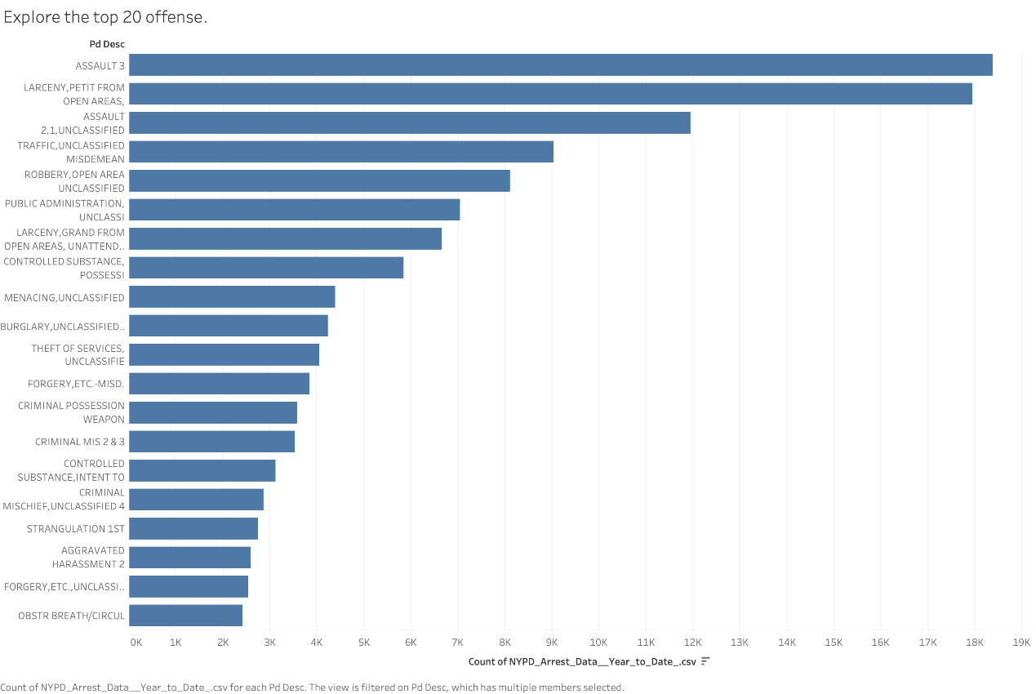

* The bar chart detailing offenses showcases "Assault 3", "Petit Larceny from Open Areas", and "Assault 2,1, Unclassified" as the top three arrest offenses.
* The prevalence of assault and larceny indicates a focus on both violent and property crimes within the city.
* The list of offenses provides insight into the types of crimes that are most frequently encountered by NYPD, with unclassified traffic incidents, misdemeanors, and public administration offenses also featuring prominently.

**Key Findings on Arrest Distribution Analysis by Borough and Perpetrator Age Group**

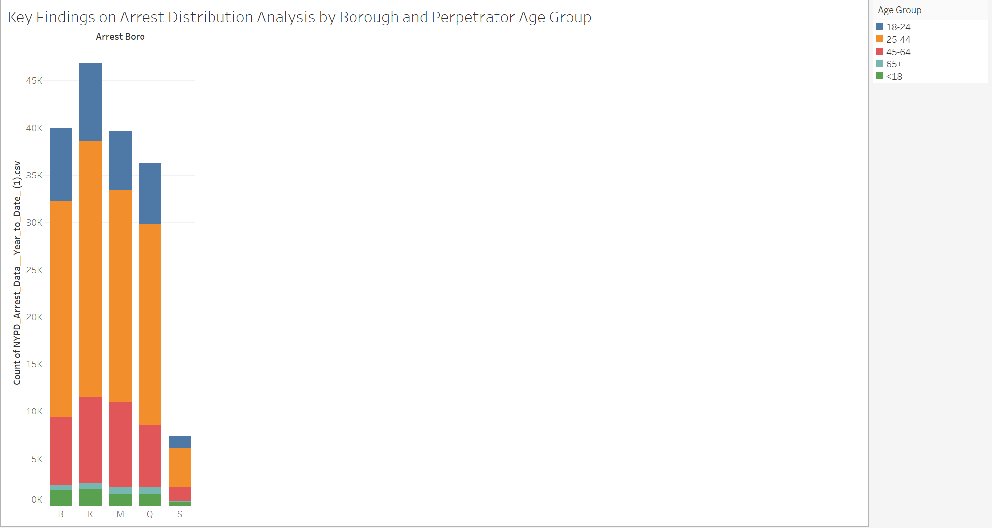

**Demographics:**

* Highest number of arrests in the age group 25-44 across all boroughs.
* Significant arrest counts in the 18-24 age group, but less than the 25-44 age group.
* Decrease in arrest frequency with increasing age, with the 45-64 age group showing fewer arrests.
* Notable arrests among the under-18 age group, particularly in the Bronx and Brooklyn.
* Minimal arrests in the 65+ age group, indicating lower criminal activity or interaction with law enforcement.

**Age Group Distribution:**

* Predominance of arrests in the prime adult age raises questions about socioeconomic factors.
* Youth arrests highlight a need for early intervention programs.
* Data suggests potential for age-targeted community policing and social support strategies.

**Spatial Dynamics of Criminal Offenses in New York City**

The analysis aims to elucidate the spatial distribution of criminal offenses in New York City, focusing on petit larceny and assault-related offenses. By integrating NYPD arrest data with geospatial mapping, we seek to understand the concentration and spread of these crimes within the city's boroughs, providing insights for law enforcement and policy development.

Offense Distribution and Density Analysis:

* **Assault and Larceny as Leading Offenses**:

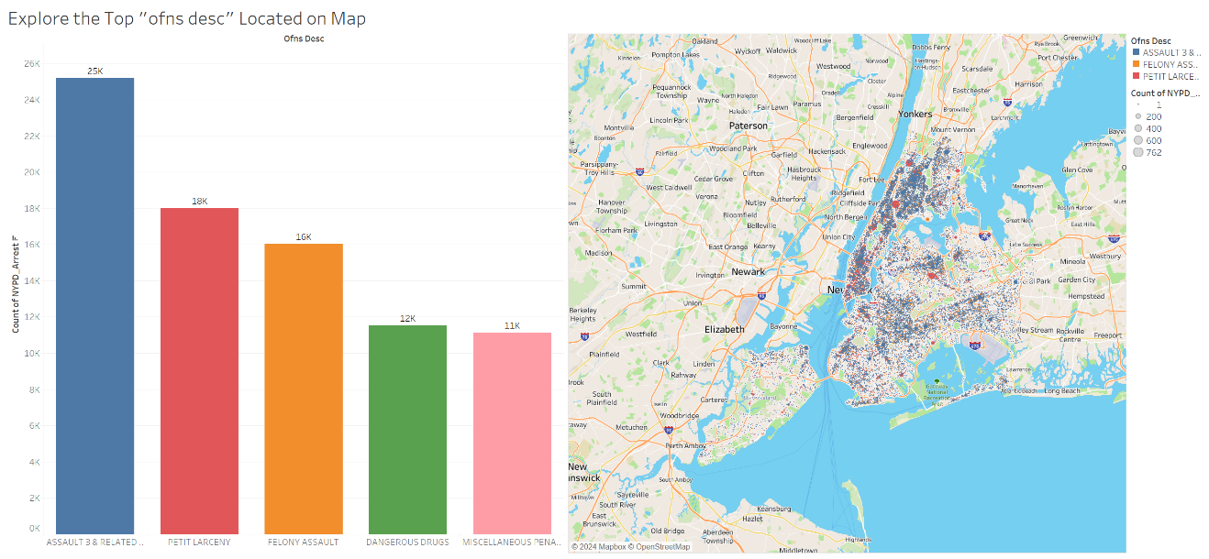

Assault 3 & related offenses have the highest arrest count at 25,000, followed by petit larceny and felony assault. This distribution indicates a pressing focus on violent and property crimes in the city.

* **Geographical Hotspots**:

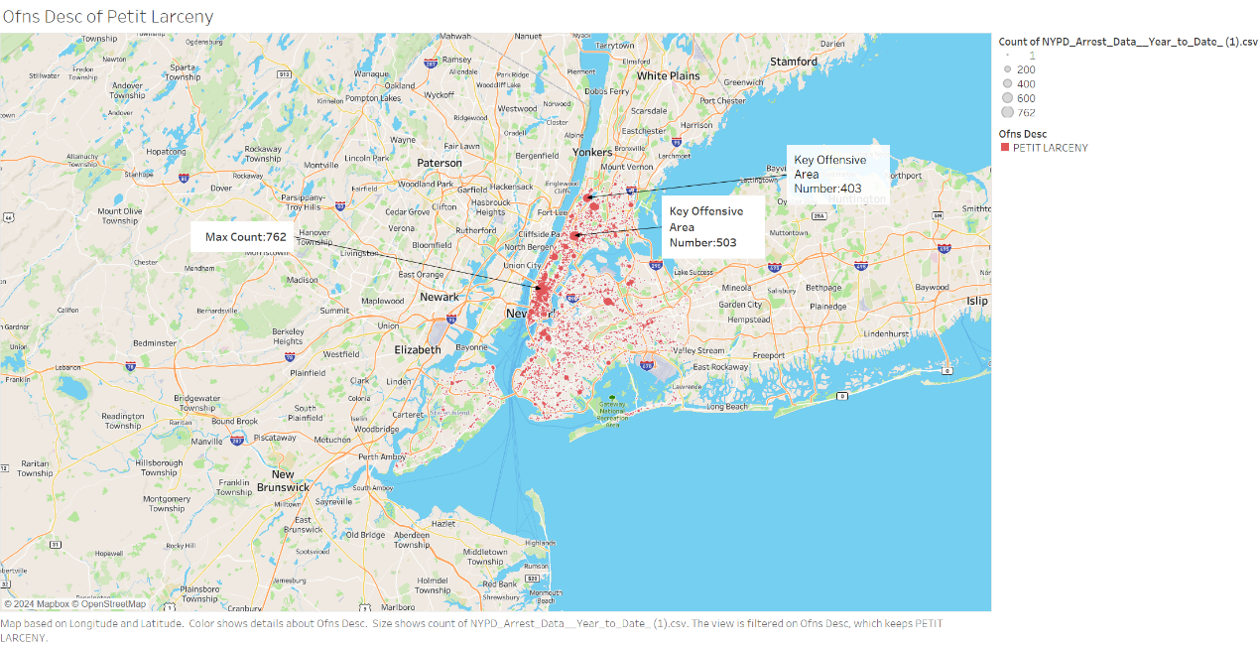

Dense clusters of offenses, particularly petit larceny, are observed in Manhattan and the Bronx, with notable hotspots identified in Herald Square and surrounding areas.

* **Petit Larceny Focus**:



Petit larceny shows an alarmingly high frequency with a maximum count of 762 at a single location, emphasizing the need for targeted anti-theft strategies.

* **Assault Pattern Observations**:

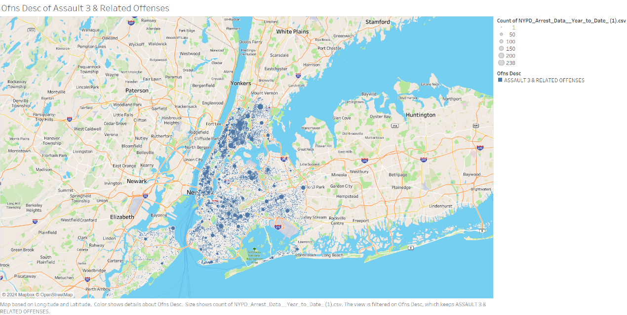

Assault 3 & related offenses are more dispersed throughout the city compared to petit larceny, suggesting different underlying factors affecting their spread.

The study highlights the dominant patterns of petit larceny and assault in New York City, revealing distinct spatial concentrations that necessitate tailored prevention measures. The findings reinforce the need for a multi-faceted approach, combining increased police presence in hotspots with community-based prevention programs. Ongoing analysis is crucial to adapt strategies in real-time and effectively reduce crime rates.

**Conclusions**

The comprehensive analysis of NYPD arrest data reveals nuanced demographic trends and offense patterns. Key findings show a pronounced number of arrests among young adult males, particularly within Black and Hispanic communities, suggesting a critical area for policy intervention and community support programs. The data also highlights a significant gender disparity in arrests across all offense levels, emphasizing the need for in-depth analysis into social factors that contribute to these discrepancies. Offense analysis pinpoints petit larceny and assault as prevalent crime types, with specific geographic hotspots indicating potential areas for targeted law enforcement and prevention efforts. Conclusively, the data underscores the importance of a strategic approach in addressing crime in New York City, advocating for continuous analysis to guide effective and equitable public safety measures.

**References窗体顶端**

Wikimedia Foundation. (2023a, August 23). *Herald Square*. Wikipedia. https://en.wikipedia.org/wiki/Herald_Square

Kreps, D. (2019, December 22). *New York State contributes $3.7 million to Universal Hip Hop Museum in Bronx*. Rolling Stone. https://www.rollingstone.com/music/music-news/new-york-universal-hip-hop-museum-bronx-930463/

Structurae. (n.d.). *Marble hill – 225th street subway station (Broadway – seventh avenue line) (Manhattan, 1907)*. https://structurae.net/en/structures/marble-hill-225th-street-subway-station-broadway-seventh-avenue-line

Publisher data.cityofnewyork.us. (2024, January 19). *NYPD arrest data (year to date)*. Catalog. https://catalog.data.gov/dataset/nypd-arrest-data-year-to-date